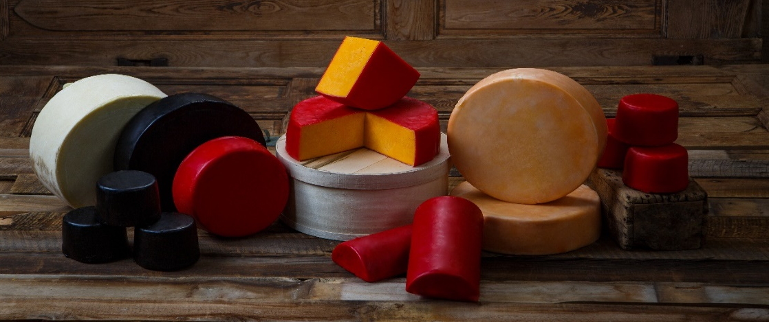
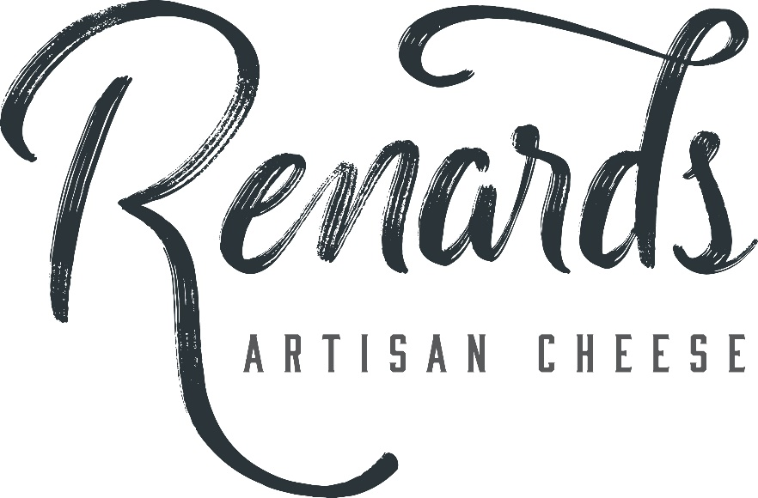

STYLE | AVG WEIGHT | PIECE DIMENSIONS (approximate) | PACKAGING | MASTER CASE SIZE | CHEESE TYPES
GEM*  (bandage-style wheel) | 3# | 4 ½” X 5 ½” | Fiber box  Case of 6  Each gem box is 6” x 6” x 5” | 17 5/8” x 6 ¾” x 9” | All varieties of Cheddar, Colby, Farmers, & Monterey Jack
MIDGET* and  SPLIT MIDGET*  (bandage-style wheels) | 12# / 6# | Midget: 4 ½” x 9 ½”  Split midget:  4 ½” x 4 ½” x 9 ½” | Fiber box | 9 5/8” x 4 5/8” x 10 ½” | All varieties of Cheddar, Colby, Farmers, & Monterey Jack
HORN* and  SPLIT HORN*  (waxed) | 13# / 7# | Horn: 6” x 12”  Split horn: 6” x 3” x 12” | Fiber box  Horn (case of 4)  Split horn (case of 2 or 4) | Horn: 12” x 12 5/8” x 14”  Split horn: 6” x 6” x 13 7/8”  Split horn: 12 ¼” x 6” x 13 7/8” | All varieties of Cheddar and Colby
DAISY*  (bandage-style wheel) | 22# | 4” x 14” | Fiber box or wood box | Fiber box:  13 1/8” x 4” x 13 5/16”  Wood box: 5 ¼” x 15 1/8” | All varieties of Cheddar, Colby, Farmers, & Monterey Jack
FLAT*  (bandage-style wheel) | 38# | 7” x 15 ½” | Wood box | 7 ½” x 16 ¼” | All varieties of Cheddar, Colby, Farmers, & Monterey Jack
BLOCK | 40# | 14 ¼” x 11 ½” x 7” | Fiber box | 11 3/8” x 7 1/16” x 14 ½” | All varieties of Cheddar, Colby, Farmers, & Monterey Jack
Available Bulk Cheese Style Options
*all wheels and horns are available in clear, red, or black wax

